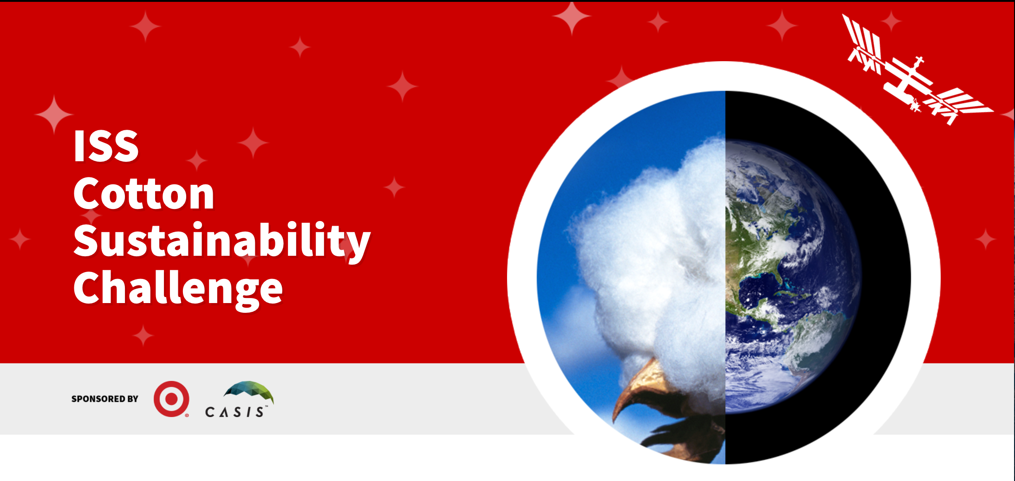

The ISS Cotton Sustainability Challenge
Cotton is an integral part of our daily lives. Many of the consumer products that we use today, from t-shirts, to jeans, to bed sheets, to coffee filters, are derived from cotton. It is estimated that more than 25 million tons of cotton are produced around the world each year. While the economic and personal benefits of cotton are well understood, the environmental impacts of cotton production are significant. It is estimated that to produce one kilogram of cotton requires thousands of liters of water. Additionally, the intensive use of agricultural chemicals in cotton farming and production can have health impacts on workers and surrounding ecosystems. Organizations around the world are looking for new and innovative ways to address this critical issue over the next few decades.
The ISS Cotton Sustainability Challenge invite leading researchers in the fields of life sciences, physical sciences and remote sensing to propose new experiments on the ISS to address cotton sustainability.
The winning proposal(s) will receive up to one million dollars in funding and support to send their research to space. This includes travel expenses and exclusive behind the scenes access to NASA facilities during the build, testing and launch phases. On the space station, a variety of physical and biological phenomena can be tested in ways not possible on Earth. In addition, the remote sensing capabilities of the space station can provide a unique vantage point for looking back at earth, which can have novel agricultural applications. We invite you to be part of the new era of research in space.
Challenge Scope
Researchers are encouraged to submit concepts focused on, but not limited to: fluid dynamics or fluid flow to improve seed germination and plant water use efficiency, testing of different cotton cultivars exposed to microgravity to monitor gene expression and water stress, and remote sensing applications to improve cotton production through crop monitoring.

Design an experiment, to be tested on ISSNL, leveraging the space and micro gravity environment to identify variables that make cotton growth more efficient and sustainable on Earth by reducing water dependencies and/or optimizing chemical use that can be applied to small scale farmers across the globe. Final results and potential benefits of this experiment will be published and considered public information.

Process and Timeline
- September 5th 2017– Contest launches
- September 19th 2017 – Challenge Webinar: Kickoff
- October 3rd 2017 – Challenge Webinar: Plant & Water (Life Sciences & Physical Sciences / Materials) with Featured Speaker TBD
- October 12th 2017 – Challenge Webinar: Remote Sensing & Earth Observation with Featured Speaker TBD
- November 8th 2017 – Project Summary Submission Deadline
- November 8th 2017 – December 15th 2017- CASIS Works with Contestants on Final Drafts of Project Summaries and Contestants Selected for Semi-Finalist Participation
- December 15th 2017 – March 1st 2018 – Deep Dives on Project Summaries
- March 15th 2018 – Finalists Announced
- March 15th – April 15th 2018 – Pitch Competition
- April 23rd 2018 : Earth Day – Winner(s) Announced

Program Eligibility
- The submitting entity must be a US corporation, citizen and/or academic entity
  - Potential international entrants are encouraged to partner with a US corporation, citizen and/or academic entity to meet elgibiltiy requirements
- The submitting entity/entrant must be 18 years old
  - Students are encouraged to partner with a mentor, teacher, parent if they want to participate

How to get started in the ISS Cotton Sustainability Challenge
The first stage in the ISS Cotton Sustainability Challenge submission process is to provide a clear one-page summary of your project. Your project summary will be competitively reviewed by an expert panel to determine if the project qualifies for a full project proposal submission. If selected, a team of ISS experts will work with you to complete your proposal to optimize your project and satisfy the unique operational conditions of the International Space Station U.S. National Laboratory.

Project Summaries are due by November 8, 2017 and must be submitted via the online form.
Complete submission details are available at https://www.iss-casis.org/cottonsustainabilitychallenge/

Format for Project Summaries Submissions

Summary: Please describe the proposed project. An abstract is appropriate, as is a less technical and more generalized overview. It is essential that this section clearly calls out:
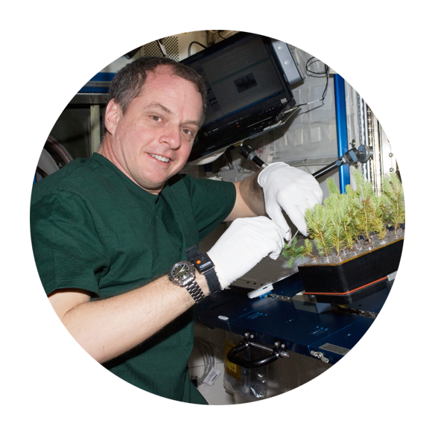
- Why is ISS a necessary platform (e.g. need for microgravity, extreme condition of space or vantage point). If the project can be accomplished in the lab down the hall, then it should be done there. We must show a unique use of the ISS.

- What is the relevance of the proposed space-based research to ground applications (e.g., healthcare advancements, commercial product development), in agreement with the CASIS mission to use the International Space Station U.S. National Laboratory for benefits to life on Earth.
Hypothesis: Clearly state the hypothesis. If the project is hardware development or technology demonstration, a short statement of objective is appropriate.

Management: In this section, it is sufficient to provide the names and titles of key team members. Additional information on qualifications of the team is also appropriate, but please be concise (keeping in mind the recommendation to keep this document under one page in length).

Economic Benefit and Commercial Relevance: This section should describe the potential influence of the project on specific commercial sectors. If appropriate, give brief details regarding market size, potential commercialization partners, and time to market. Does this project lead to new revenue or increased speed to market? Does it show leverage from other sources? Will the projects’ outcomes stimulate new markets or significantly change existing ones? Are the projects’ outcomes leverageable across other applications, needs, customers or markets?

Innovation: Explain the importance of the project toward knowledge advancement and thought leadership. Will the projects’ outcomes lead to new knowledge / tools and / or open new solution pathways that would not have been possible without this project? Does the research provide the partner organization with a leadership position?

Benefit to Humankind and Social Impact: Does the project build an enduring capability for cotton farmers? At project completion, will the project develop new capabilities, processes, infrastructure, or human capital to help prepare the world for the challenges of the 21st Century? Does the project have a catalytic impact? Will the project directly drive (motivate / stimulate) likeminded endeavors? Does the project save lives and/or improve the quality of lives?

Budget: Preliminary estimate of you development cost. Note, there are other costs associated with flying the project which we will help you estimate as the project concept evolves.

Scientific Research Areas

Life Sciences
Earth benefits from spaceflight R&D span the biomedical, biotechnology, and agricultural industries. Learn more

Physical Sciences
In the absence of gravity, scientists can do experiments in the physical sciences that are difficult or even impossible on the ground. Learn more

Remote Sensing
The ISS provides a unique vantage point for observations of Earth and space. Learn more

Researchers are encouraged to submit concepts focused on, but not limited to: fluid dynamics, fluid flow, cotton or plant germination. Different cultivars of cotton genetics, exposed to microgravity, water uptake and gene expression. Data generated from the research experiments selected will be provided to the public, with the hope that the discoveries made can be leveraged by other researchers and product developers.

ISS Cotton Sustainability Challenge: Project Summary Submission

Project Title:

Entity Name: | Project Lead:
Contact Email: | Contact Phone:
Date: | Entity Location: (Please note, non-U.S. entities must have a U.S.-based partner to submit a proposal)
Summary:
Hypothesis:
Management:
Economic Benefit and Commercial Relevance:
Innovation:
Benefit to Humankind and Social Impact:
Budget:

